# Determine Triangle Type

# Design Document

# 1. Introduction

This document is generated to describe how “Determine Triangle Type” java program is designed and developed.

This simple java program takes the length of the triangle’s three sides as input, and returns whether the triangle is Equilateral, Isosceles or Scalene.

In this document the Class Diagram is described.

# Class Diagram:

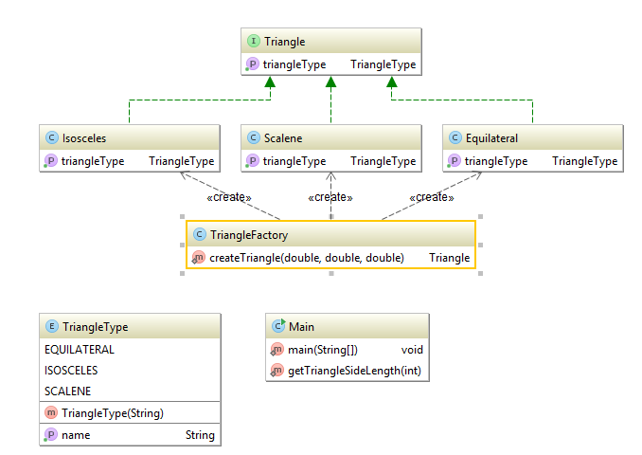

# Solution:

As the diagram illustrates, I have used factory design pattern in order to hide complexity of code behind an interface and to increase coherence as well as loose coupling.

I have implemented a Triangle interface with three concrete class which implement the “getTriangleType()” method of their interface and return their type as either an “Equilateral”, an “Isosceles” or a “Scalene”.

There is a factory class called “TriangleFactory” which is responsible to return desired type based on input parameters and it has a createTriangle() method which instantiates and returns a specific triangle based on input parameters.

In the main method this simple line of code instantiates and returns the type of Triangle based on input parameters.

Triangle myTriangle = TriangleFactory.createTriangle(side1, side2, side3);